FAQs
- When do I register my warranty?
We would recommend you to register your Grundfos product warranty as soon as possible. If registered within 14 days, you enjoy an additional 6 months warranty.
You can register your Grundfos product warranty online here. Do note that warranty coverage starts from the date of purchase as indicated in the original sales invoice.
- During registration of my warranty online, I encounter the error messages. What should I do?
For successful registration, please ensure the following steps have been completed:
a. All entries in the mandatory fields (marked with *) are filled in
b. The E-warranty number is entered correctly

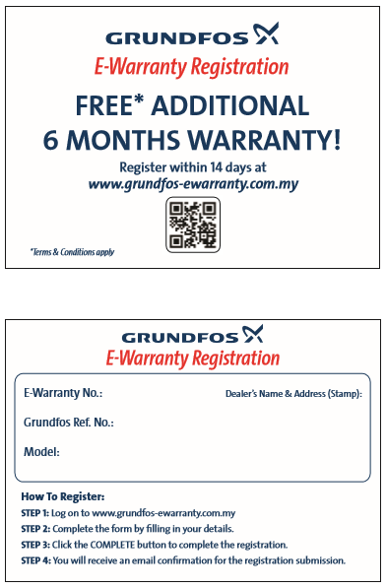

 | Error Message | What You Need To Check
1 | Invalid E-warranty number | Verify that you have entered the correct E-Warranty number. It is stated on your E-warranty card.  If the error persists, please email us.
2 | Invalid Date | Check that the date of purchase is within the last 2 years.  If you received your product later than the date you purchased it, please key in the delivery or collection date instead.  If the error still persists, please email us.
4 | Different model name | If the model in our system is different from the one you purchased, please email us.
- What does my warranty cover?
Warranty will be on the product due to manufacturing defects commencing from the date of purchase. The number of months the warranty covers will be within your warranty details PDF file sent to you.
Within the warranty period, Grundfos shall carry out the repair or replacing of parts at Grundfos' option, ex-factory or ex-authorised Grundfos Service Centre, any product of Grundfos' manufacture.
- What does my warranty NOT cover?Grundfos will not be liable for any costs of removal, installation, transportation, or any charges which arise in connection with this warranty claim.
Grundfos will not be liable for any replacement of parts caused by normal wear and tear, damage caused by dry running, cavitation, unsuitable operating condition, unfavourable electric supply, mishandling, flooding, lightning, unauthorised alteration or repair, misapplication and product which is installed not in accordance to Grundfos installation and operating instructions.

- How would I know if my warranty has been successfully registered?
Upon successful registration, an e-warranty registration receipt will be forwarded to the given e-mail address.

- Who do I contact if my pump needs servicing (both under warranty or past warranty period)?
You may either call Grundfos Pumps Sdn Bhd at the toll free number 1 800 88 PUMP (7867), or approach your nearest Grundfos Authorised Dealer.

Grundfos Pumps Sdn Bhd
7, Jalan Peguam U1/25
Glenmarie Industrial Park
40150 Shah Alam, Selangor

www.grundfos.com.my
email : sales_my@sales.grundfos.com

